





Love2Shops Mobile Hybrid

  - Account Management

Version: 2.2
Jun 22 2017
Author: Linh Luu

Software Development & Business Process Services

110 Bishopsgate, London
EC2N 4AY
Tel: +44 (0)20 7333 0033
Email: info@nashtechglobal.com


Table of Contents
1. Overview 4
2. Actor List 4
3. Preconditions 4
4. Flow of Events 4
4.1 Register New User 4
4.2 User Login 20
4.3 Touch ID Setting 28
4.4 Change Password 31
4.5 Update User Details 37
4.6 Change PIN Code 44
4.7 Payment Method Setting 48
4.8 Reset Password 54
4.9 Change Email Address 57
4.10 Logout 62
5. Assumptions 63
6. Notes 63

Document History

Document Version History
Version | Date | Edited by | Details
0.1 | May 5 2017 | Linh Luu | Document Creation
1.0 | May 16 2017 | Linh Luu | Submit 1st document to PG
1.1 | May 30 2017 | Linh Luu | Submit 2nd document to PG
2.0 | Jun 14 2017 | Linh Luu | Submit document (v2.0) to review by PG
2.1 | Jun 19 2017 | Linh Luu | Submit document (v2.1) to review by PG
2.2 | Jun 22 2017 | Linh Luu | Update final feedback
Approvers
Distribution List
Name | Role | Signature | Date | Version
Confidentiality
This document is distributed on a restricted basis, is commercial in confidence to the recipient, and may not be used for any purpose other than that associated with a NashTech project. The contents of this document may not be disclosed to any third parties without the expressed advance written authorisation of NashTech.

Overview
The use case describes below satisfies the following business requirements:
Ref | Requirement Name
1 | The user must be able to process all the actions related to Account Management:  - Register new user  - User login  - Touch ID Setting  - Change password  - Update personal details  - Change PIN code  - Payment method setting  - Reset password  - Change email address  - Logout

Actor List
# | Actor
1 | Public/ Non-Registered user
2 | Registered user

Preconditions
The user must have the Loves2shop installed on the device.

Flow of Events

Register New User
Actor | Public user
Pre-condition | The user does not have the account in Love2shop
Post-condition | A new account has been created

Activity Diagram

Application Screen
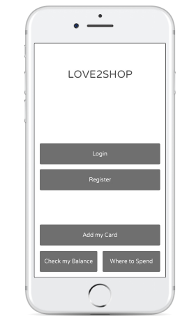  Screen 1 | 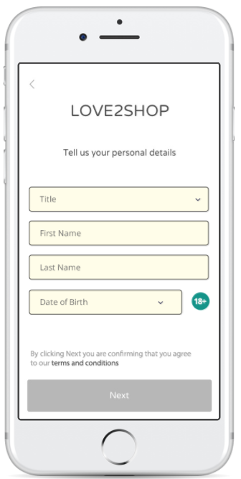  Screen 2 | 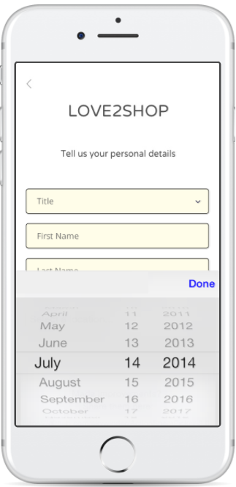  Screen 3
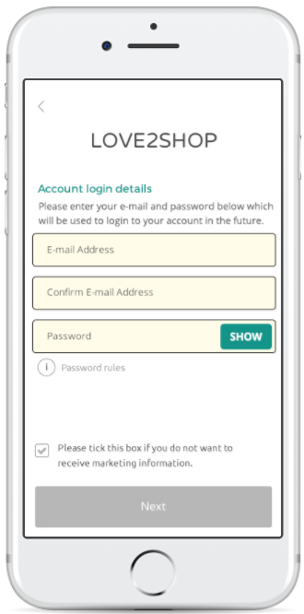  Screen 4 | 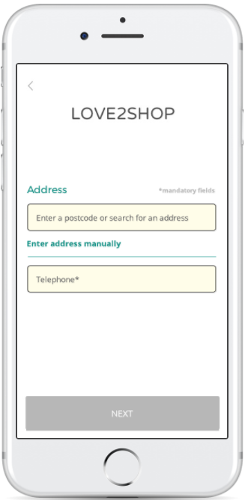  Screen 5 | 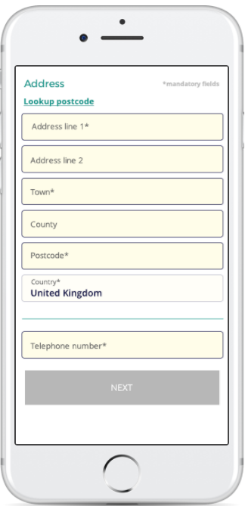  Screen 6
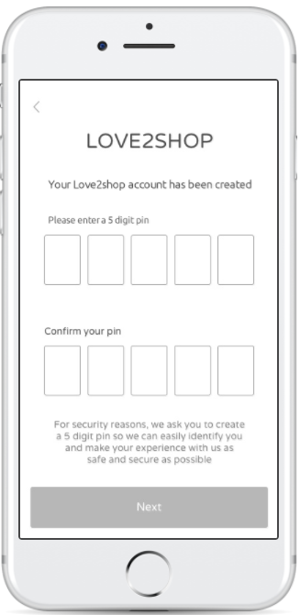  Screen 7 | 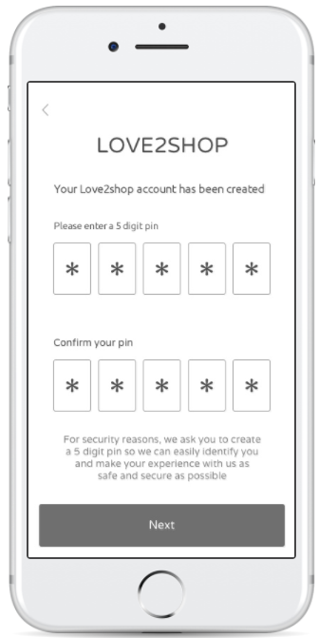  Screen 8 | 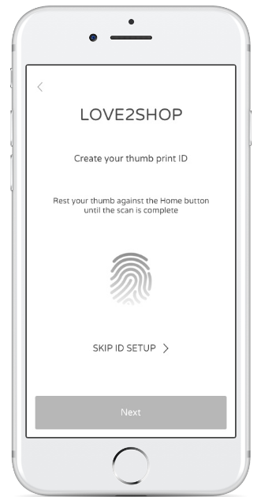  Screen 9
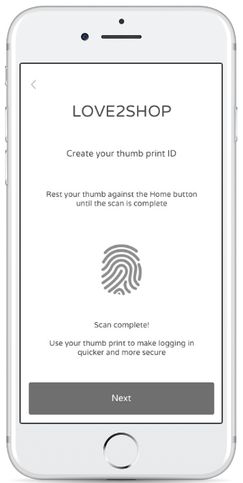  Screen 10 | 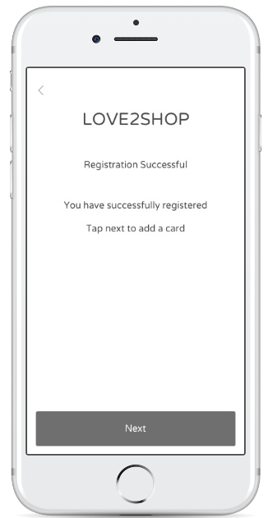  Screen 11 | 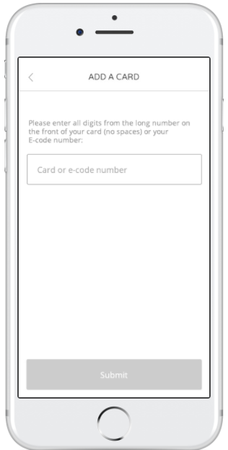  Screen 12

Field name | Type | Default text | Required | Validation
Title | Dropdown | Blank | Y | Contains:  - Blank (Default value)  - Mrs  - Mr  - Miss  - Ms  - Dr
First Name | Text | N/A | Y | Min 2 characters  Max 25 characters  Must not contain special characters: $@!%*#?&,£ ()=+"
Last Name | Text | N/A | Y | Min 2 characters  Max 25 characters  Must not contain special characters: $@!%*#?&,£ ()=+"
Date of Birth | Date | N/A | N | Min 18 (Age)  Max 99 (Age)  Format: DD Month YYYY (e.g. 04 August 1981)  DD from 1 to 31  Month from January to December  YYYY from 1917 to <current year – 18>
Password | Text | N/A | Y | The password must be displayed as “•”.
Email | Text | N/A | Y | Min 6 characters  Max 40 characters  Email address should not contain illegal characters (ex: $%^…)
Confirm Email | Text | N/A | Y | Min 6 characters  Max 40 characters  Email address should not contain illegal characters (ex: $%^…)
Phone | Numeric | N/A | Y | Home phone  + Start with 01 or 02 or 0845  + Length equals 11  Mobile phone  + Start with 07 and length equals 11 or 10  + Start with 03 and length equals 11
Address search | Text | Enter a postcode or address | N
Address Line 1 | Text | N/A | Y | Min 2 characters  Max 40 characters
Address Line 2 | Text | N/A | N | Max 40 characters
Town | Text | N/A | Y | Min 1 characters  Max 40 characters  Must not contain special characters: $@!%*#?&,£()=+"
County | Text | N/A | N | Max 40 characters  Must not contain special characters: $@!%*#?&,£()=+"
Postcode | Text | N/A | Y | Min 1 character  Max 8 characters  Must not contain special characters: $@!%*#?&,£()=+"
Country | Text | United Kingdom | Y | Read-only
PIN code | Numeric | N/A | Y | 5 digits  The PIN code and the confirmation code must be displayed as “*”.
Marketing information | Checkbox | Please tick this box if you do not want to receive marketing information | N

Basic Flow
Step | Event Description
1. | After opening the Love2shop application, the user can:  - Clicks on the “Registration” button on Screen 1 to create an account, go to step 2    - Or clicks on the Add My Card button on Screen 1, refer to Register via Add Card  - Or clicks on the Check my Balance button on Screen 1, refer to Register via Check Balance
2 | The application will open a screen to allow users input personal info (screen 2)
3 | The user inputs personal details include:  - Title  - First Name  - Last Name  - Date of Birth  Then click on Next button.
4 | The application will validate fields according to data dictionary definition and according to BR01:  - If failed, make the border of the error fields in red and display the error message below them.  - Else, call web service to retrieve the password validation rule and open screen 4 for user enters account login details.
5 | The user inputs account login details (screen 4) includes:  - Email Address  - Confirm Email Address  - Password (shown as *)  - Show password. By clicking on Show Password button, password is visible to user.  - Tick on the checkbox to confirm that they do not want to receive marketing information  The click on Next button.
6 | The application will validate user-entered detailed fields according to BR02 and BR06 and according to Data Dictionary definition :  - If failed, make the border of the error fields in red and display the error message below them.  - Else, request web service to check if the email has been used for another account:  - If fail, pop up an error message  - Else, open screen 5 for user enters address information. Go to step 7
7 | The user can search for an address
8 | Once the user enters from 3 characters in the postcode address search field, the application will validate and search for results based on an address searched from the PCA service:  - If no result returns, show “No results found” in the suggestion  - Else, return the list of results
9 | The user can select a result from the suggestion
10 | The application:  - Display the address fields with the information from the selected result (screen 6): Address line 1, Address line 2 , Town, County, Postcode, Country  - Display Lookup Postcode option to back to the current screen
11 | The user enters phone number and click on Next button
12 | The application checks if missing phone number:  - If yes, make the border of the error fields in red and display the error message below them.  - Else, call web service to create an account:  - If fail, pop up error message  - Else, navigate the user to screen 7 to enter PIN with the following info is displayed:  - Successful message: Your love2shop account has been created  - Option to enter PIN  - Option to confirm PIN  - Notification message  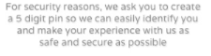
13 | The user setups the PIN code then clicks on the Next button.
14 | The application will validate the PIN code according to BR05:  - If fail, pop up an error message  - Else, check if the touch ID is available on the device  - If yes, enable Touch ID access on this device  - Else, go to step 17
15 | The user validates Touch ID on the application (screen 9)
16 | The application will check if the fingerprint is matched with the one in the device settings according to BR04:  - If yes, enable Touch ID for this account and show screen 10. Go to step 17  - Else, pop up an error message. (Allow the user to close the error message and decide to skip Touch ID Setup on screen then go to step 18)
17 | The user clicks on Next button on screen 10
18 | The application navigates user to successful registration screen (screen 11)
19 | The user clicks on Next button on successful registration screen
20 | The application navigates user to Add a card screen (screen 12)

Alternative Flow – Enter user address manually
Step | Event Description
1. | From step 7 of Basic Flow, the user clicks on Enter Address Manually (screen 5) to enter address manually
2 | The application will show the following fields (screen 6)  - Address Line 1  - Address Line 2  - Town  - County  - Post code  - Country
3 | The user enters address manually then clicks on Next button
4 | The application validates address information accordingly the definition in Data Dictionary:  - If fail, make the border of the error fields in red and display the error message below them.  - Else, go to step 11 from basic flow.

Sub Flow – Show password rules
Step | Event Description
1. | The user clicks on the hint icon on the entering account login details (screen 4)
2 | The application will show the content of password rule (available within the application when requested to Password Policy service):  - Header: Creating your password  - Content: <Content>  - Control: OK button
3 | The user clicks on OK button to close the message and stay in the registration screen with all current data.

Sub Flow – Skip ID Setup
Step | Event Description
1. | After setting the PIN code, the user clicks on Next button to setup Touch ID (screen 8)
2 | The application displays the Touch ID setup screen (screen 9)
3 | The user clicks on “Skip ID Setup”.
4 | The application pop up message on screen:  - Message: Are you sure you want to skip ID Setup?  - Control: OK button  - By clicking on OK button, set Touch ID is OFF on this device for this account and show screen 11

Sub Flow – Register via Check Balance
Screen 1 | 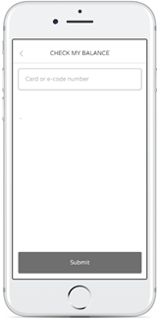  Screen 2 | 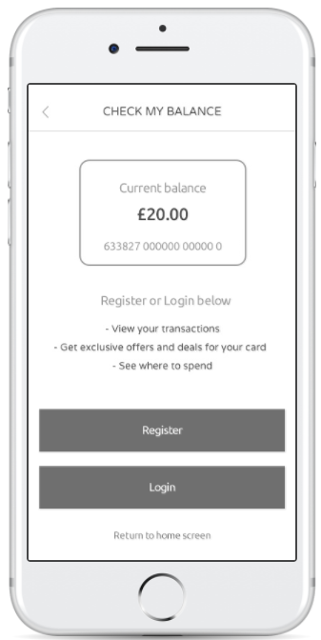  Screen 3

Step | Event Description
1 | On the Homepage for unregistered user, the user clicks on the “Check my Balance” button (screen 1)
2 | The application navigates user to check balance screen (screen 2)
3 | User checks the card balance – Refer to Card Management UC - Check Balance
4 | When successful check card balance, the application opens screen 3
5 | User clicks on the Register button on screen 3
6 | Continue with step 2 of basic flow.

Sub Flow – Register via Add Card
Screen 1 | 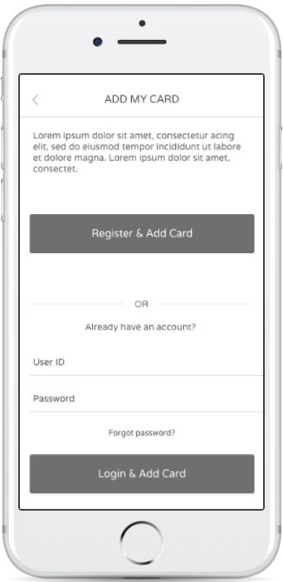  Screen 2

Step | Event Description
1. | On the Homepage for unregistered user, the user clicks on the “Add my Card” button (screen 1)
2 | The application opens Add My Card screen (screen 2)
3 | The user clicks on Register & Add Card button
4 | Continue with step 2 of basic flow.

Business Rules
Business Rule ID | Name | Description
BR01 | Date of birth | User must be over 18 years old to be accepted and registered. The system must calculate user’s age based his/her full date of birth. For example, if a user was born on the 1st December 2000 then he/she cannot register in November 2013 as he/she is still under 18 years old.
BR02 | Email and confirm email | The email and confirm email fields must be matched.  Must be with email address format:  [A-Z0-9._%+-]+@[A-Z0-9.-]+\.[A-Z]{2,4}  Cannot register with used email address.
BR03 | Telephone | Must be registed with UK phone number  Home phone  + Start with 01 or 02 or 0845  + Length equals 11  Mobile phone  + Start with 07 and length equals 11 or 10  + Start with 03 and length equals 11.
BR04 | Touch ID | The fingerprint must be matched with the one in the device settings
BR05 | PIN code | Must be 5 digit numbers  The PIN code and the confirmation code fields must be matched.
BR06 |  | The application will return the content of passwordPolicyFriendlyMessage from Password Policy service for these cases:  - Pop up an error message when user enters invalid password  - Show password policy to user when user clicks to show password rule.

Web service Parameters – Password Policy
This service returns a list of password validation rules, which must be adopted when validating a new password.

Web service Parameters – Validate Email Address
This service will check whether an account already exists on the system with a particular email address.

Web service Parameters – PCA
PCA is the 3rd party web service so we don’t need to identify the request here.
The technical team will submit check PCA and make sure to return the required information for Response

Web service Parameters – Create Account
This service will create a Love2shop personal account for a customer following submission of user’s personal details, password and any other required info (e.g. acceptance of T&Cs).

Message
Field | Case | Format | Message Description
All required fields | Required | Red border | Required
First Name | Contain special characters | Red border | First Name contains invalid characters
First Name | Validation length | Red border | First Name must be at least 2 characters in length.
Last Name | Contain special characters | Red border | Last Name contains invalid characters
Last Name | Validation length | Red border | Last Name must be at least 2 characters in length.
Date of Birth | User must be at least 18 years old to be accepted and registered. | Red border | User must be at least 18 years old to be registered on this site.
Confirm Email | Email and confirm email fields are not matched. | Red border | Email and confirmation email do not match
Email | Contains Illegal characters or illegal format | Red border | You must enter a valid email address.
Telephone | Invalid format | Red border | Invalid Phone Format
Address 1 | Validation length | Red border | Address Line 1 can be no less than 2 characters in length.
Address 2 | Validation length | Red border | Address Line 2 can be no less than 2 characters in length.
Town | Validation length | Red border | Town can be no less than 2 characters in length.
Postcode | Contain special characters/ fail to validate length | Red border | Invalid postcode
PIN | PIN code not match | Pop Up | PIN codes do not match.
PIN | Not enough 5 digits | Pop Up | The PIN code must be a number of 5 digits.
Touch ID | The fingerprint is not matched with the one in the device settings | Pop Up | Invalid Touch ID. Please try again
 | Success = FALSE but not return any error code (connection lost, etc.) | Pop Up | Unexpected issue happened. Please try again.

For Nash Tech internal testing, please check the following cases:
- Invalid password

User Login
Actor | Registered user
Pre-condition | Registered user  Application installed
Post-condition | Authenticated user

Activity diagram

Application Screen
Screen 1 | 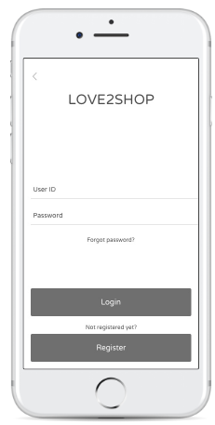  Screen 2 | 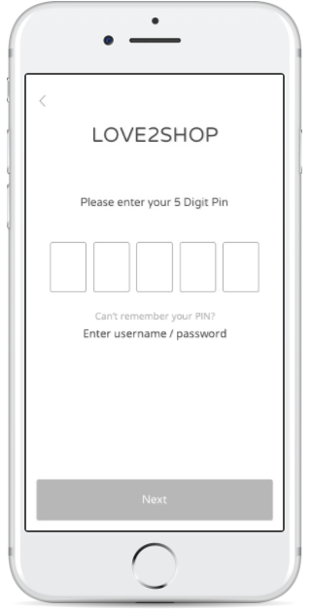  Screen 3
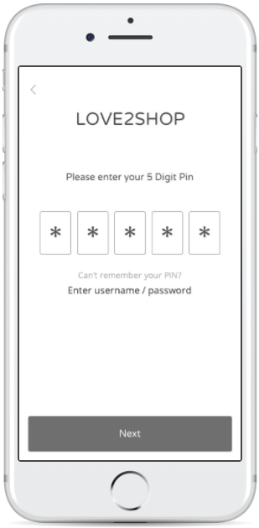  Screen 4 | 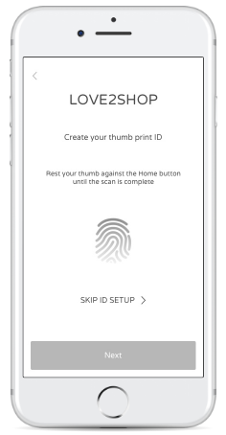  Screen 5 | 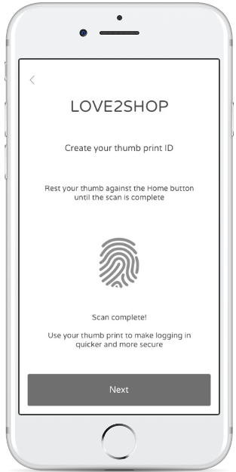  Screen 6
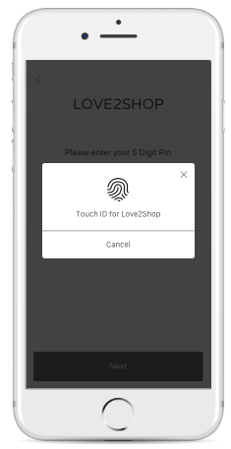  Screen 7 | 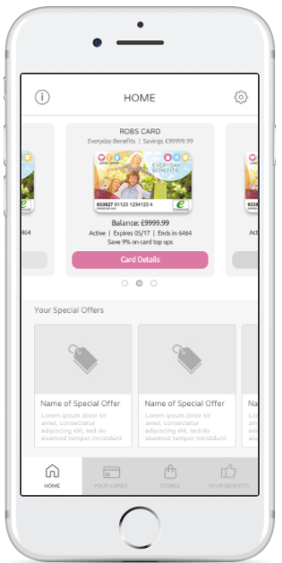  Screen 8 | Screen 9

Field name | Type | Default text | Required | Validation
User ID | Text | N/A | Y | Min 6 characters  Max 40 characters  Email address should not contain illegal characters (ex: $%^…)
Password | Text | N/A | Y | The password must be displayed as “•”.
PIN code | Numeric | N/A | Y | 5 digits  The PIN code and the confirmation code must be displayed as “*”.

Basic Flow
Step | Event Description
1. | User opens the Love2shop application
2 | The application checks whether active user on the device:  - If yes, check if Touch Settings = ON and have Touch ID available in the device settings:  - If yes, refer to Alternative Flow – Returning user Touch ID  - Else, refer to Alternative Flow – Returning user PIN  - Else, go to step 3
3 | User enters registered username and password  Then click Login button
4 | The application validates fields on screen 2 according to BR01:  - If fail, show error message.  - Else, request web service to validate email address and password:  - If fail, pop up error message  - Else, check if 1st time login of this account on the device:  - If no, call web service to check if having card in the wallet:  - If yes, when successful login, show homepage screen for registered user (screen 8)  - Else, when successful login, show Add Card screen (screen 9)  - Else, go to step 5
5 | The user sets up PIN then clicks on Next button.
6 | The application will check if correct PIN format and confirm PIN matches:  - If failed, pop up error message, go to step 5  - Else, continue checking if have touch ID on the device  - If yes, go to step 7  - Else, show error message
7 | The user setups Touch ID to decide to enable Touch ID access on this device
8 | The application will check if fingerprints match:  - If yes, enable Touch Setting is ON. Go to step 9  - Else, pop up error message. The user can decide to skip the Touch ID matched (refer to Sub Flow – Skip ID Setup)
9 | The application calls web service to check if no card available in the wallet:  - If fail, pop up error message  - Else, The application displays the Add a card screen to user if no card available in the wallet (screen 9) else displays the Homepage for unregistered user (screen 8)

Alternative Flow – Login via Add Card
Screen 1 | Screen 2

Step | Event Description
1. | On the Homepage for unregistered user, the user clicks on the “Add my Card” button (screen 1)
2 | The application will display Add My Card screen (screen 2)
3 | The user clicks on the Login & Add Card button
4 | Process from step 3 of the Basic Flow

Alternative Flow – Returning user Touch ID
Step | Event Description
1 | From step 2 of basic flow, the application opens screen 7 having PIN entry in the background and show the fingerprint option overlying for the user scans fingerprint
2 | The user scans their fingerprint to validate with any Touch ID in the local device
3 | The application will check if matching Touch ID according to BR03:  - If fail, pop up error message “Touch ID is not correct”. Go back to step 2  - If fail attempts Touch ID 3 times, pop up error message: “Fail attempts Touch ID 3 times “ (Allow the user closes the message and navigate user to enter PIN screen (screen 3))  - Else, call web service to check if having card in the wallet:  - If yes, show homepage screen for registered user (screen 8)  - Else, show Add Card screen (screen 9)
4 | The user clicks on Cancel button (screen 7) to login by PIN (screen 3) – refer to Returning user PIN

Alternative Flow – Returning user PIN
Step | Event Description
1 | From step 2 of basic flow, the application opens Screen 3 for users enter PIN code
2 | The user enters PIN  Then clicks on Next button.
3 | The application validates whether or not matching PIN code according to BR02  - If fails, pop up error message “PIN is not correct”  - If fail attempt PIN 3 times, pop up error message: “Fail attempts PIN 3 times “, go to step 4  - Else, call web service to check if having card in the wallet:  - If yes, show homepage screen for registered user (screen 8)  - Else, show Add Card screen (screen 9)
4 | The user is able to click on “Enter username/ password” if fail attempts PIN code 3 times
5 | The application opens Screen 2 for users enter username and password
6 | The user can enter username and password to login up to 5 times
7 | The application calls web service to validate username and password according to BR04:  - If fail, pop up error message  - Else, call web service to check if having card in the wallet:  - If yes, show homepage screen for registered user (screen 8)  - Else, show Add a card screen (screen 9)

Business Rules
Business Rule ID | Field Name | Description
BR01 | Email Address | Min 6 characters  Max 40 characters  Email address should not contain illegal characters (ex: $%^…)
BR02 | PIN code | Must be 5 digit numbers  A PIN is unique for an account in a device  Number of PIN attempt is limited 3 times.
BR03 | Touch ID | The touch ID must be the touch registered in the local device setting.  Number of Touch ID attempt is limited 3 times.
BR04 |  | An account will be locked if fail to enter username and password 5 times and this case will be handled by web service.

Web service Parameters – Authenticate User and Retrieve Account
This service authenticates the user based on email address and password.

Web service Parameters – Retrieve Cards
This service returns a list of cards that are associated to the user’s account.

Message
Field | Case | Format | Message Description
All required fields | Required | Red border | Required
PIN | Incorrect PIN | Pop up | PIN is not correct
PIN | Incorrect PIN 3 times | Pop up | Fail attempts PIN 3 times
Touch ID | Incorrect Touch ID | Pop up | Touch ID is not correct
Touch ID | Incorrect Touch ID 3 times | Pop up | Fail attempts Touch ID 3 times
Email | Contains illegal characters or illegal format | Red border | Incorrect email address
 | Success = FALSE but not return any error code (connection lost, etc.) | Pop up | Unexpected issue happened. Please try again.
For Nash Tech internal testing, please check the following cases:
- Incorrect username or password up to 5 times (The message is returned from web service includes the message for locked account)

Touch ID Setting
Actor | Registered User
Pre-condition | User have been logged into the system
Post-condition | Update Touch ID

Activity Diagram

Application Screen
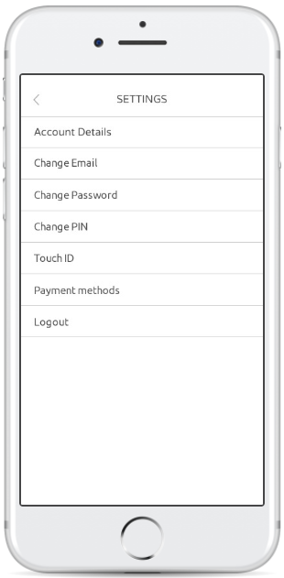  Screen 1 | 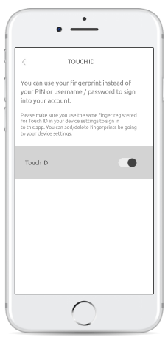  Screen 2 | 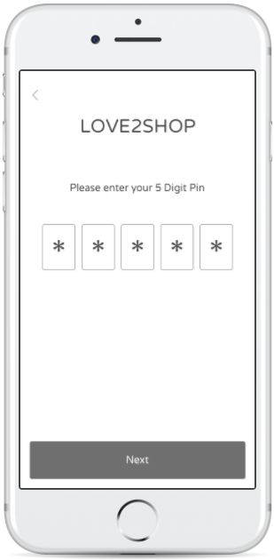  Screen 3

Field name | Type | Default text | Required | Validation
PIN | Numeric | N/A | Y | 5 digit numbers  The PIN code must be displayed as “*”.

Basic Flow
Step | Event Description
1 | User click on Touch ID button on Setting screen (screen 1)
2 | The application check if available touch ID on the local device:  - If yes, navigate user to Touch ID setting screen  - Else, display an error message: “not available Touch ID in the local device”
3 | The user changes Touch ID setting (screen 2)
4 | User enters PIN to validate the changes (screen 3)
5 | The application verifies the inputted PIN number:  - If failed, pop up an error message  - Else, show Touch ID screen with Touch ID is ON

Business Rule
Business Rule ID | Name | Description
BR01 | PIN | Must be 5 digit numbers

Message
Field | Case | Format | Message Description
PIN | Required | Red border | Required
PIN | Incorrect PIN | Pop Up | PIN is not correct

Change Password
Actor | Registered user
Pre-condition | User have successfully logged in.
Post-condition | The user’s password is modified and will need to be used at the next logon attempt.

Activity Diagram

Application Screen
Screen 1 | 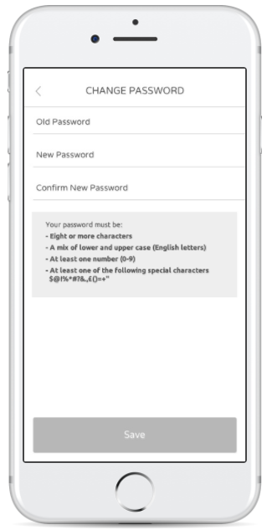  Screen 2 | 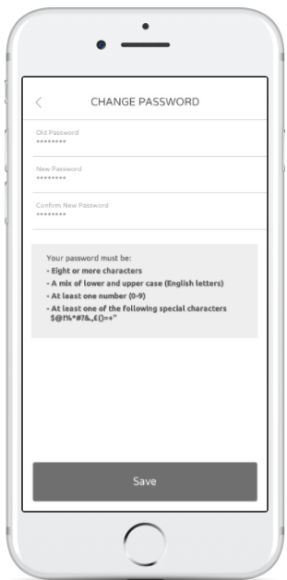  Screen 3

Field name | Type | Default text | Required | Validation
Password (Old password, new password, confirm new password) | Text | N/A | Y | Password must be displayed as “•”.

Basic Flow
Step | Event Description
1 | User clicks on Change Password button on Setting screen
2 | The application calls web service to show password rule info on screen 2:  - If fails, navigate user to Change password screen with no password rule is display.  - Else, navigate user to Change password screen and display password rule
3 | User enter the following information:  - Old Password  - New Password  - Confirm New Password  Then click on Save button
4 | The application will check if missing password and passwords do not match:  - If failed, show error message accordingly  - Else, submit to the web service to validate the changes:  - If failed, pop up an error message  - Else, display a successful message

Business Rule
Business Rule ID | Name | Description
BR01 | Old password | The application will return the content of passwordPolicyFriendlyMessage from Password Policy service if user enters invalid password
BR02 | New password | The application will return the content of passwordPolicyFriendlyMessage from Password Policy service if user enters invalid password
BR03 | Confirm new password | The application will return the content of passwordPolicyFriendlyMessage from Password Policy service if user enters invalid password  The password and confirm password must be matched.

Web service Parameters – Password Policy
This service returns a list of password validation rules, which must be adopted when validating a new password.

Web service Parameters – Update Password
This service allows an authenticated user to update their password. The new password will be validated against the password policy.

Message
Field | Case | Format | Message Description
All required fields:  - Old Password  - New Password  - Confirm New Password | Required | Red border | Required
Confirm new password | Do not match  With New password | Red border | New password and confirm new password do not match.
 | Success = FALSE but not return any error code (connection lost, etc.) | Pop Up | Unexpected issue happened. Please try again.
The following cases are required for internal testing:
- Incorrect password
- A notification email will be sent to your email address

Update User Details
Actor | Registered user
Pre-condition | User have successfully logged in.
Post-condition | The user’s details are updated.

Activity Diagram

Application Screen
Screen 1 | 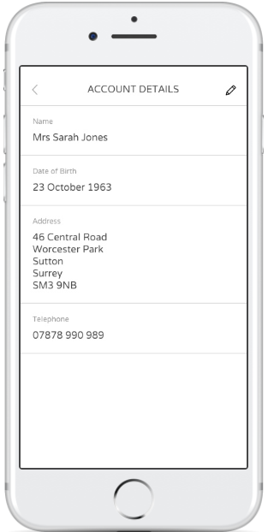  Screen 2
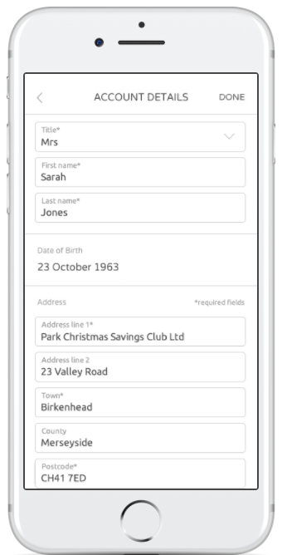  Screen 3 | 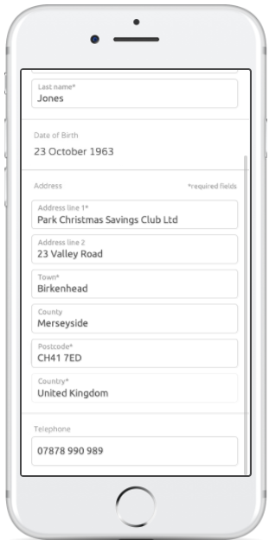  Screen 4

Field name | Type | Default text | Required | Validation
Title | Dropdown | <Current Value> | Y | Contains:  - Current value (Default value)  - Mrs  - Mr  - Miss  - Ms  - Dr
First Name | Text | N/A | Y | Min 2 characters  Max 25 characters  Must not contain special characters: $@!%*#?&,£ ()=+"
Last Name | Text | N/A | Y | Min 2 characters  Max 25 characters  Must not contain special characters: $@!%*#?&,£ ()=+"
Date of Birth | Date | N/A | N/A | Read only
Address Line 1 | Text | N/A | Y | Min 2 characters  Max 40 characters
Address Line 2 | Text | N/A | N | Max 40 characters
Town | Text | N/A | Y | Min 1 characters  Max 40 characters
County | Text | N/A | N | Max 40 characters  Must not contain special characters: $@!%*#?&,£()=+"
Postcode | Text | N/A | Y | Min 1 character  Max 8 characters  Must not contain special characters: $@!%*#?&,£()=+"
Country | Text | United Kingdom | Y | Read-only
Phone | Numeric | N/A | N | Home phone  + Start with 01 or 02 or 0845  + Length equals 11  Mobile phone  + Start with 07 and length equals 11 or 10  + Start with 03 and length equals 11

Basic Flow
Step | Event Description
1 | User click on Account Details button on Setting screen (screen 1)
2 | The system calls web service to retrieve account details and load all information into Account Detail screen (screen 2)
3 | User selects to Edit icon and enter new account details
4 | The application will validate the updated exactly like in Registration New User:  - If failed, show the messages like Registration New User  - Else, request the web service to update user details  - If failed, pop up error message accordingly  - Else, show a successful message

Web service Parameters – Retrieve Account
This service retrieves the user’s personal details. The user is identified via the access token passed in the Authorization header.

Web service Parameters – Update Account
This account updates the user’s personal details.

Message
Field | Case | Format | Message Description
All required fields | Required | Red border | Required
First Name | Validation length | Red border | First Name must be at least 2 characters in length.
First Name | Contain special characters | Red border | First Name contains invalid characters
Last Name | Validation length | Red border | Last Name must be at least 2 characters in length.
Last Name | Contain special characters | Red border | Last Name contains invalid characters
Telephone | Invalid format | Red border | Invalid Phone Format
Address 1 | Validation length | Red border | Address Line 1 can be no less than 2 characters in length.
Address 2 | Validation length | Red border | Address Line 2 can be no less than 2 characters in length.
Town | Validation length | Red border | Town can be no less than 2 characters in length.
County | Contain special characters | Red border | County must not contain special character
Postcode | Contain special characters or fail to validation length | Red border | Invalid postcode
 | Success = FALSE but not return any error code (connection lost, etc.) | Pop Up | Unexpected issue happened. Please try again.

Change PIN Code
Actor | Registered user
Pre-condition | User have successfully logged in.
Post-condition | The PIN code is updated and will need to be used at the next logon attempt

Activity Diagram

Application Screen
Screen 1 | 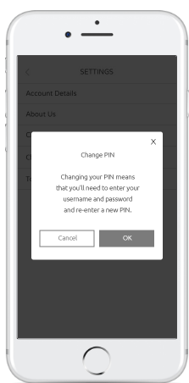  Screen 2 | 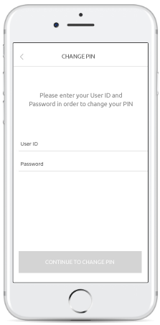  Screen 3
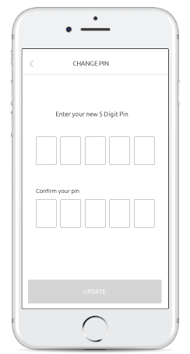  Screen 4 | 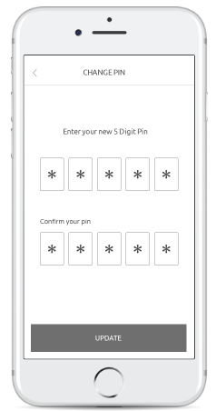  Screen 5

Field name | Type | Default text | Required | Validation
UserID | Text | N/A | Y | Min 6 characters  Max 40 characters  Email address should not contain illegal characters (ex: $%^…)
Password | Text | N/A | Y | Password must be displayed as “•”.
PIN | Numeric | N/A | Y | 5 digit numbers  The PIN code and the confirmation code must be displayed as “*”.

Basic Flow
Step | Event Description
1 | User selects option Change PIN Code in the Setting screen
2 | The application will show the notification like Screen 2 to ask for user’s confirmation to update PIN code.
3 | The user agrees to change PIN code.
4 | The application will show Screen 3 and let user enter UserID and Password
5 | The user enters the email address, password  Then clicks on Continue To Change PIN button
6 | The application will check if missing or invalid username and password:  - If failed, highlight error field in red and display message below the error field  - Else, request Authentication User web service to validate whether the entered account already exists:  - If failed, pop up an error message  - Else, navigate users to Change PIN – Screen 4
7 | The user touches the rectangle to enter PIN
8 | The application opens a numeric keypad on screen.
9 | The user enters 5 digits PIN and confirm 5 digits PIN  Then clicks on Update button
10 | The application will check if following the PIN rule:  - If failed, show an error message  - Else, show a successful message

Business Rule
Business Rule ID | Name | Description
BR01 | PIN | Must be 5 digit numbers  New PIN and confirm PIN must be matched.

Web service Parameters – Authenticate user
This service will validate user account.

Message
Field | Case | Format | Message Description
PIN | Required | Red border | Must be 5 digit numbers
PIN (New PIN and confirm PIN) | Do not match | Red border | PIN and confirm PIN do not match.
 | Success = FALSE but not return any error code (connection lost, etc.) | Pop Up | Unexpected issue happened. Please try again.
For Nash Tech internal testing, please check the following cases:
- Invalid username and password

Payment Method Setting
Actor | Registered user
Pre-condition | User have successfully logged in.
Post-condition | The user is able to change default bank card or remove card

Activity Diagram

Application Screen
Screen 1 | 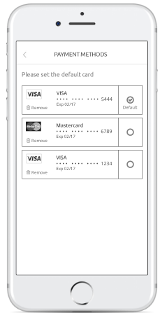  Screen 2

Basic Flow
Step | Event Description
1 | The user opens Setting screen  The click on Payment methods button
2 | System requests mid-tier service to retrieve a list of bank cards:  - If web service fails to return card list, pop up error message  - Else  - If having no payment card available, shows message “No payment cards available” below the header.  - Else, show all available bank cards on screen and the current default card.
3 | User either:  - Change the default card by ticking on the radio button of each card  - Or remove card – Refer to Remove a card  User decides to change the default card.
4 | On change default card, the application will request the web service to update:  - If failed, pop up an error message  - Else, refresh the screen with updated default card

Sub Flow – Remove a card
Step | Event Description
1 | From step 3 of Basic Flow, user clicks on remove button
2 | The application displays the confirmation message:  - Content: Are you sure you want to remove?  - Button: Yes, No
3 | User clicks on Yes to confirm card removing, go to step 4  Else clicks on No to cancel the remove action and stay at the current screen.
4 | The application will request the web service to remove a card:  - If failed, pop up an error message  - Else, refresh the list of bank cards

Business Rules
Business Rule ID | Description
BR01 | A card is displayed on the payment method screen only if the user has setup the card for future use while made payment with a bank card.

Web service Parameters – Retrieve Tokenized Cards
This service returns a list of all tokenized cards associated to an account.

Web service Parameters – Update Tokenized Cards
This service will allow the user to update the default card for their account.

Web service Parameters – Delete Tokenized Cards
This service will remove the tokenised card from the user’s account.

Message
Field | Case | Format | Message Description
 | Success = FALSE but not return any error code (connection lost, etc.) | Pop Up | Unexpected issue happened. Please try again.

Reset Password
Actor | Non-Authenticated users
Pre-condition | The user has the L2S app installed on the device.
Post-condition | A reset email will be sent to users and the user is able to login to the application using a new password.

Activity Diagram

Application Screen
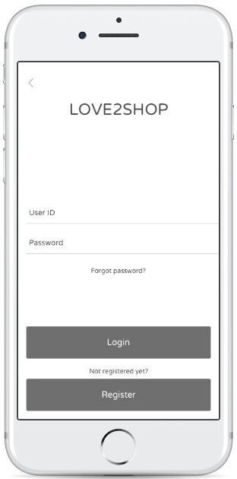  Screen 1 | 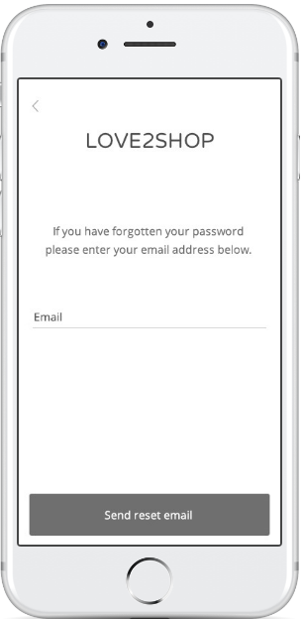  Screen 2
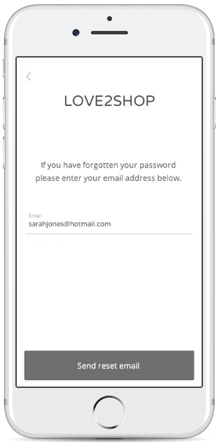  Screen 3 | 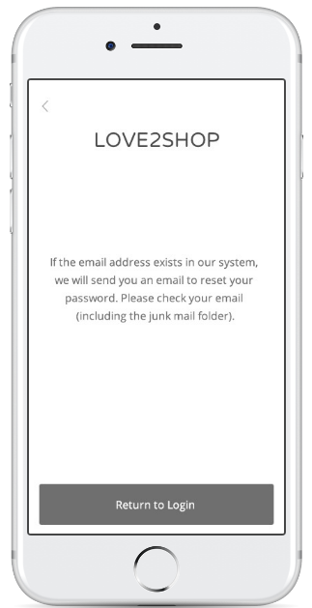  Screen 4

Field name | Type | Default text | Required | Validation
Email | Text | N/A | Y | Min 6 characters  Max 40 characters  Email address should not contain illegal characters (ex: $%^…)

Basic Flow
Step | Event Description
1 | The user selects “Forgot Password” in the Login screen – Screen 1
2 | The application shows reset password screen for user enters email address (screen 2)
3 | The user enters Email Address then click on the Reset Password button (screen 2)
4 | The application validates email if missing or incorrect format for email address:  - If failed, show error message accordingly  - Else, call web service to reset password:  - If failed, pop up an error message  - Else, show a successful message (screen 4)

Business Rule
Business Rule ID | Name | Description
BR01 | Email | Must be with email address format.

Web service Parameters – Forgot Password
This service allows a non-authenticated user to request a password reset token be mailed to them. The reset password mail will direct the user to the L2S website to reset their password.

Message
Field | Case | Format | Message Description
Email | Required | Red border | Required
Email | Contains illegal characters or illegal format | Red border | Incorrect email address
 | Success = FALSE but not return any error code (connection lost, etc.) | Pop Up | Unexpected issue happened. Please try again.
For Nash Tech internal testing, please check the following cases:
- This email is not mapping with any account

Change Email Address
Actor | Registered user
Pre-condition | The user has logged into the system
Post-condition | The user can change the current email address to a new one and next time login to the application using a new email.

Activity Diagram

Application Screen
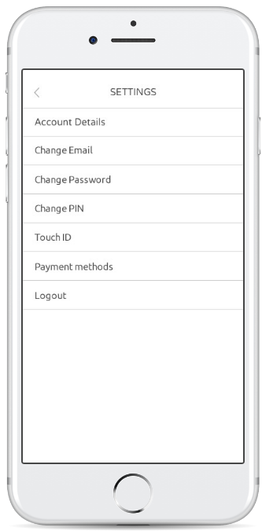  Screen 1 | 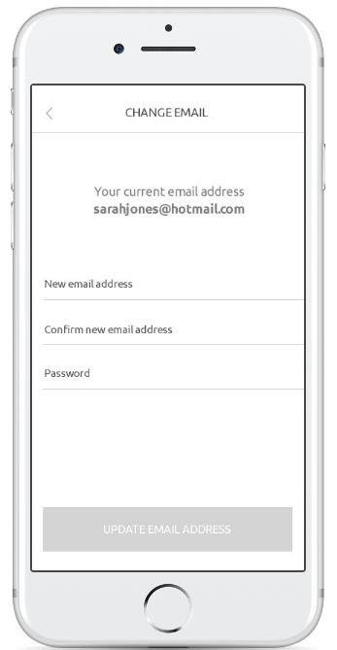  Screen 2 | 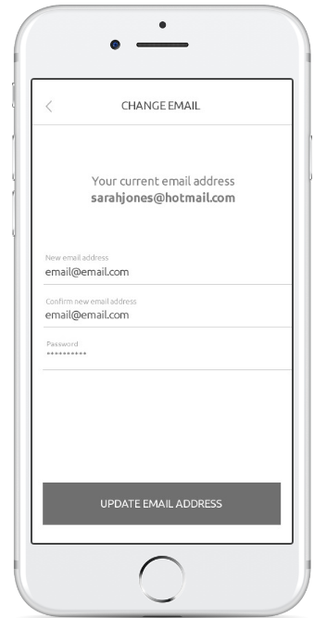  Screen 3

Field name | Type | Default text | Required | Validation
Email | Text | N/A | Y | Min 6 characters  Max 40 characters  Email address should not contain illegal characters (ex: $%^…)
Confirm Email | Text | N/A | Y | Min 6 characters  Max 40 characters  Email address should not contain illegal characters (ex: $%^…)
Password | Text | N/A | Y | The password must be displayed as “•”.

Basic Flow
Step | Event Description
1 | The user selects “Change Email” in the Setting screen
2 | The application displays Change Email screen with the following information:  - Your current email address – Read only  - New email address field  - Confirm email address field  - Password field
3 | The user enters new email address, confirm email address and current password of the current email address then click on the Update Email Address button
4 | The application will validate if missing email/ password or incorrect format for email address:  - If yes, show error message accordingly  - Else, submit the web service to update email address  - If failed, pop up error message  - Else, show the successful message

Business Rule
Business Rule ID | Name | Description
BR01 | Password | Must be the password of the current email.
BR02 | Email and Confirm Email | The email and confirm email fields must be matched.  Must be with email address format.  Cannot register with used email address.

Web service Parameters – Update Email Address
This service will validate that the email address doesn’t already exist and allow a user to update their email address.

Message
Field | Case | Format | Message Description
All required fields | Required | Red border | Required
Email | Contains illegal characters or illegal format | Red border | Incorrect email address
Confirm Email | Email and confirm email fields are not matched. | Red border | Email and confirmation email do not match.
 | Success = FALSE but not return any error code (connection lost, etc.) | Pop Up | Unexpected issue happened. Please try again.
For Nash Tech internal testing, please check the following cases:
- Incorrect password
- This email has been used for another account

Logout
Actor | Registered user
Pre-condition | The user has logged into the system
Post-condition | The user is logged out of the Love2shop system.

Application Screen
Screen 1 | Screen 2

Basic Flow
Step | Event Description
1 | The user selects “Logout” in the Setting screen
2 | The application displays confirmation message:  - Content: Are you sure you want to logout?  - Button: Cancel, OK
3 | The user clicks on the OK button to logout of the system and is navigated to Homepage screen for unregistered user - Screen 1  The user clicks on the Cancel button and stay in the Setting screen.

Business Rule
Business Rule ID | Name | Description
BR01 | Logout | The application will clear any active user in the local device.

Web service Parameters – Invalid Access Token
This service should be invoked to invalidate an access token. Access tokens should be invalidated, when a user logs out of the app

Message
Field | Case | Format | Message Description
N/A

Assumptions
Assumption ID | Description

Notes
Note ID | Description
1 | If the user decides to clear cache, the application will consider as 1st time login for the login user.
2 | 1st time login is check with the combination of Acc + Device, if a previous account using the app attempts to login again, the app will still capture the info to check if need to set up PIN and Touch
3 | The results for postcode or address search will be returned will be based on the PCA
4 | If the user logins successful, the application will use cache to resume previous screen.
5 | Register New User: PG must provide the PCA web service to analyse correctly
6 | The successful message will also be returned by the web service.
7 | The confirmation email will be sent to users that will be handled by mid-tier service.
8 | When users try to exit the application in every step, all inputted information is cleared and the user must back to register all info again.
9 | Reset Password: The mobile app only calls the mid-tier service to send out an email with the token. Using this email to reset password will not be handled by mobile app.
10 | The notification email for change email address will be sent to users that will be handled by mid-tier service
11 | Registration New User – Register via Check Balance: It is used to register in another situation. The card used to check the balance will not be added to the new account automatically.
12 | Locked password: All the rules are handled by the mid-tier service from PG so I believe that it has been included and return the corresponding error message.
13 | A token to identify the active user is valid in 24 hours (described in the web service). The application will use such information to identify current user and if in active session or not.
14 | PG noted in 14/06/2017: For registration, the country code field should default to United Kingdom. There will be NO additional options available.

